03 - 3D Spiral and Z level Finish

Introduction
In this chapter 3D Spiral and Z level finishing strategies will be applied to a model that consists of a combination of flat and steep areas plus a pocket with vertical walls.

3D Spiral Machining defines the tool Stepover relative to the 3D surface shape providing consistency over both flat areas and steep sidewalls. In this exercise applying this toolpath to the complete model without using Boundaries would not be recommended. Although this toolpath maintains a constant Stepover there is nothing to prevent the tool plunging with a full width cut into the deep pocket area.
Boundaries used correctly will limit the 3D Spiral toolpath to the flatter areas leaving the remaining steep areas to be machined using the Constant Z strategy.

- Open a millimeter milling document.
- Import the file camera.igs. The import wizard is displayed.
- Click Use the wizard to establish the initial setup location and stock size and click Next four times.
- On the stock dimensions page click Compute stock size from the size of the part and click Finish.
- Select an isometric view.
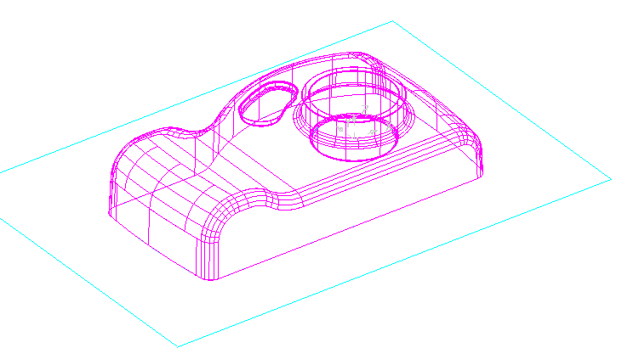

This model is a good example of where it is a better option to use more than one finishing strategy. 3D spiral and Z level finish strategies will be used and they will be they will be kept separate by being limited by slope boundaries.

We are now in a position to define a 3D spiral operation. Certain types of Boundary are calculated based on the Active tool.
The Tolerance and Thickness values in the Boundary forms are important and normally reflect the same Tolerance and Thickness values with the subsequent toolpaths applied to them.

- Select the Feature step. Select Surface milling and click Next.
All of the part surfaces should already be listed in the part surfaces page so click Next. (If they are not listed, drag select them and click the plus button.)
- Check Choose a single operation.
- Click 3D spiral and click Next twice.
- Click Use slope region boundary, enter a Slope angle of 30 and click Finish.
- Run a Centerline simulation.
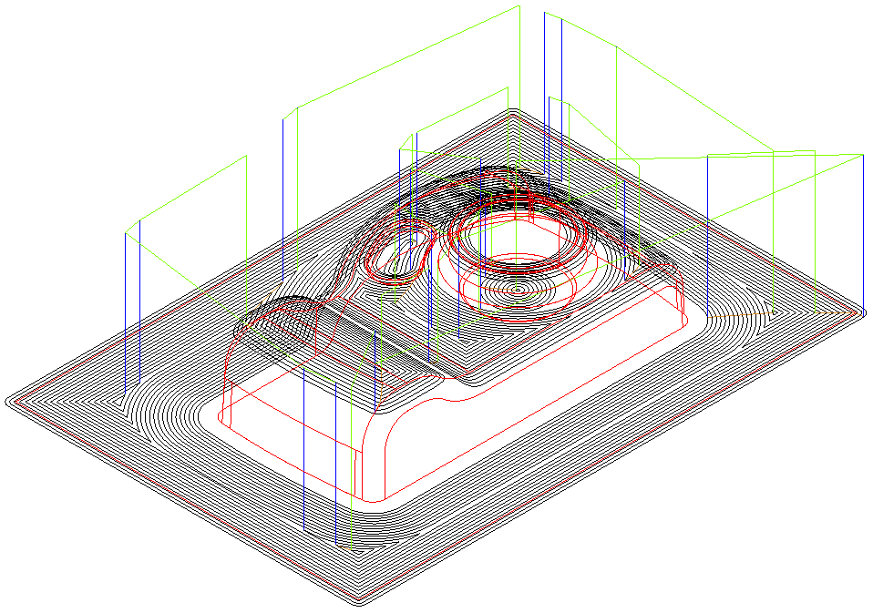
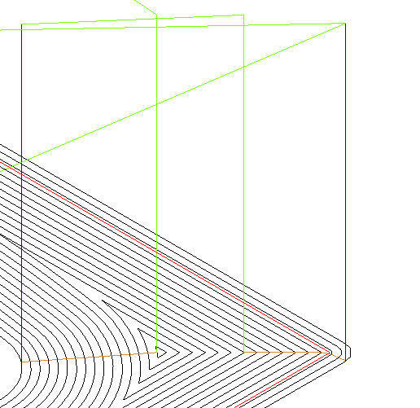

The areas of the model that are inclined at less than 30 degrees to the horizontal are machined in a series of parallel offset passes. The passes are linked on the surface by feedrate moves. Longer moves are linked with rapid moves.

- Edit the feature again.
- Click on the finish1 operation and click on the Milling tab.
- Click the Spiral checkbox and click OK.
- Run a centerline simulation.
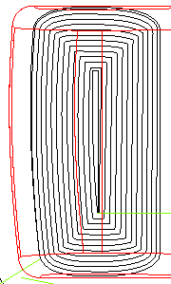

The Spiral option is ideal for HSM (High Speed Machining) applications where toolpaths should be as continuous as possible with the minimum sudden changes direction. You can see that instead of concentric offset toolpaths, the paths are now a continuous spiral.

Z level machining
Constant Z machining projects each tool track horizontally onto the component at fixed heights defined by the Stepdown. This also sometimes known as waterline machining.

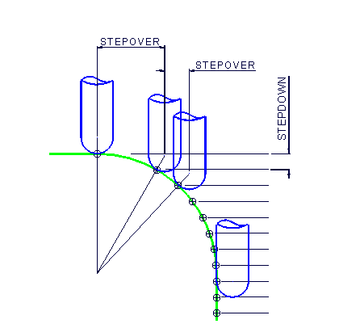

In Z level machining a constant stepdown is used in the Z direction between each pass. As the component surface becomes shallow the actual tool step over increases until it becomes non-existent on flat areas. For this reason it is a good idea to limit the toolpath to a slope boundary so that only the areas with a good surface finish are retained. By using a combination of 3D Spiral and Z level machining together with appropriate slope boundaries the whole part can be machined to a good surface finish.

- Edit the Feature.
- Uncheck the spiral operation.
- Click on srf_mill 1 in the tree window.
- Select the Process tab & click Add a new operation.
- Check Z Level and Finish.
- Select Z Level in the tree view.
- Select the Boundaries tab.
- Check Use part surfaces as boundary (this is required to prevent the tool from machining the outer edge of the part).
- Select the Slopes tab.
- Check Vertical only and set the minimum slope angle to 30
- Click Apply, then OK.
- Run a Centerline simulation.
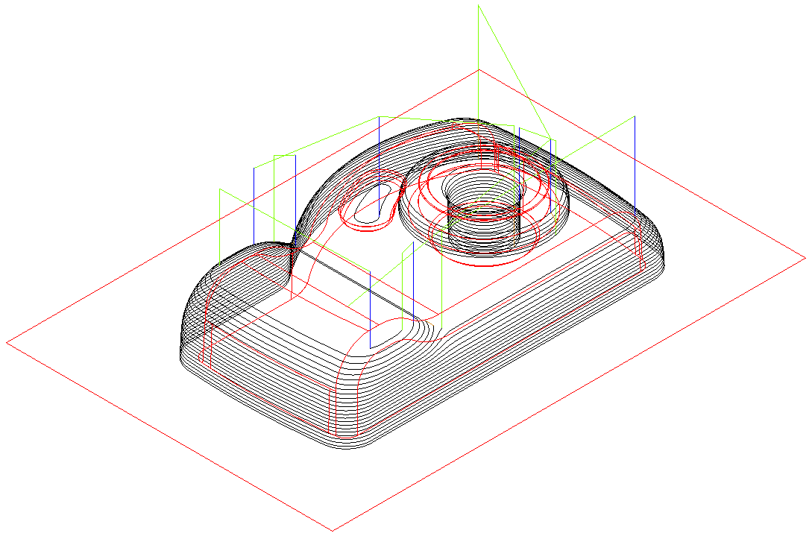
Only the areas of the model that are steeper than 30 degrees to the horizontal have been machined. We will now simulate the two operations together to see the finished process.

- Edit the feature.
- Click on srf_mill 1
- Select the Process tab.
- Check the box next to Spiral.
- Run a Centerline simulation.

The 3D spiral process is cutting the material left on the steep side of the part before the Z Level machining has cleared it. Where there are deep steep walls this may result in cutter damage.

- Edit the feature.
- Click on srf_mill 1 in the tree view.
- Select the Process tab.
- Drag the Z Level operation above the Spiral operation.
- Press Apply then OK.
- Run a Centerline simulation.
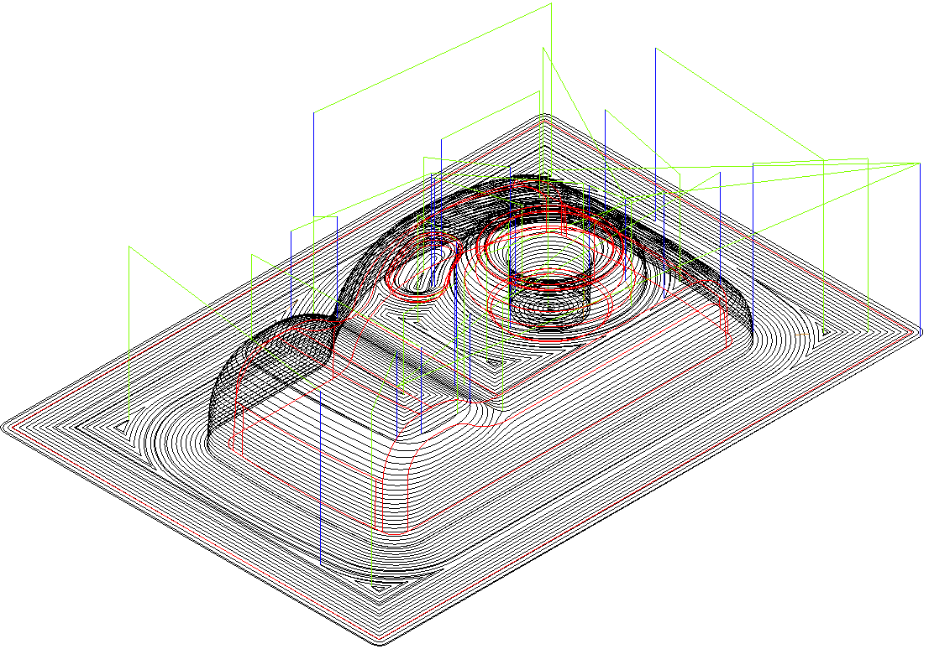

The toolpaths are now executed in the correct order.

Interleaved Spiral Machining

This strategy is a mixture of Z Level and 3D Spiral machining. Where the model is steep, Constant Z is used and for other areas, 3D offset is used. The method uses a default slope angle of 30 degrees to separate the steep and shallow areas.

- Edit the feature.
- Select srf_mill 1 in the tree view.
- Select the Process tab.
- Uncheck all of the operations.
- Click on the Add a new operation button.
- Check Z Level and press Next.

- Check the options on the form as shown below.

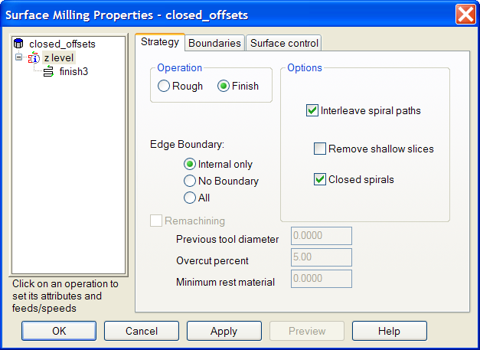

- Press Finish.
- Run a Centerline simulation.
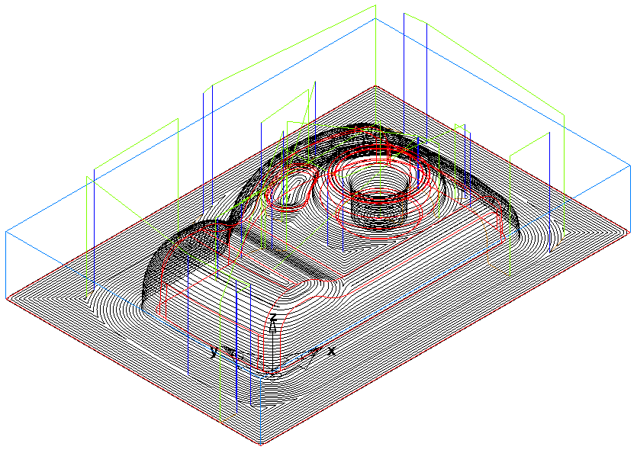

Note the way that the shallow and steep areas are now linked together and the machining runs from the top down.

When high speed machining it is desirable to have as few sharp changes in direction as possible in the toolpath. In the next example the toolpaths will be generated with open offsets. This will give more lift offs, resulting in more air time, however, as the toolpath can be run at a higher feedrate this is acceptable.

- Edit the feature
- Click on Z Level in the tree view.
- Select the Strategy tab.
- Uncheck Closed offsets.
- Press Apply and then OK.
- Run a Centerline simulation.

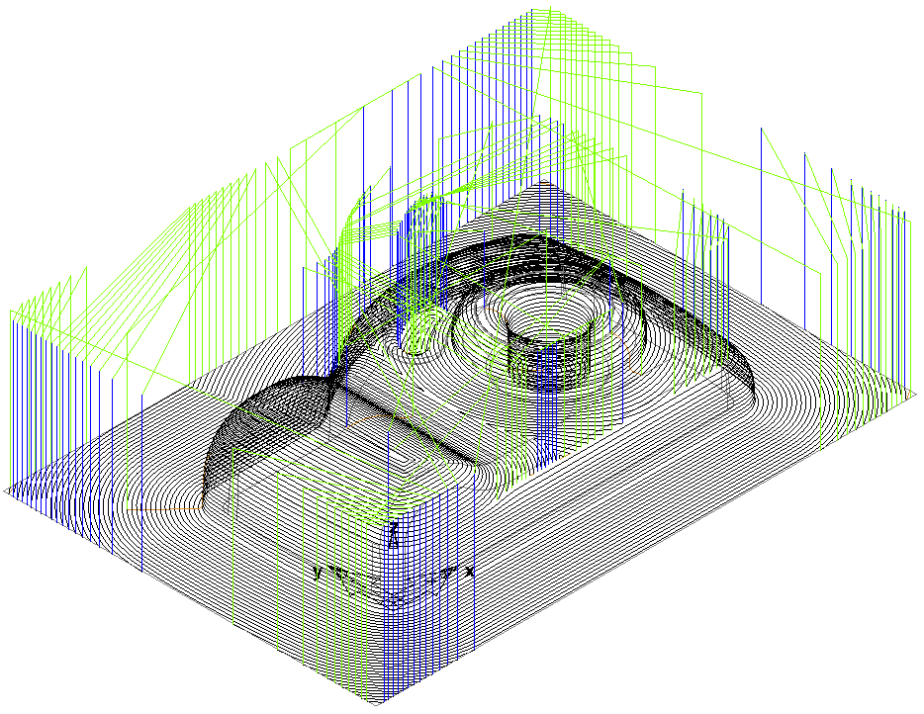

The finished high speed toolpath.

